**UONGOZI WA OFISI YA RAIS NA MWENYEKITI WA BARAZA LA MAPINDUZI ZANZIBAR (OFISI KUU – ZANZIBAR)**

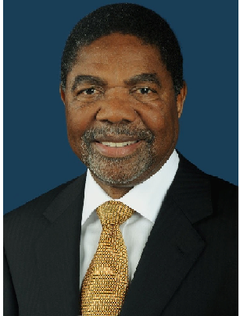

**HONOURABLE HIS EXCELLENCY DRT. ALI MOHAMED SHEIN.**

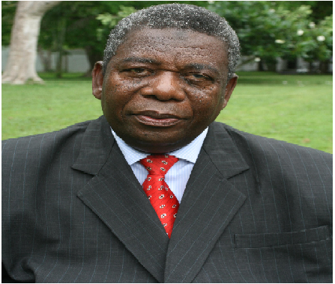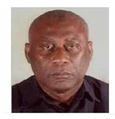

**PRESIDENT OF ZANZIBAR AND CHAIRMAN OF REVOLUTIONARY COUNCIL**

CHIEF SECRETARY OF THE REVOLUTIONARY COUNCIL

**HONOURABLE DRT. ABDUL-HAMID YAHYA MZEE**

REVOLUTIONARY COUNCIL

MINISTER OF STATE, PRESIDENT’S OFFICE AND CHAIRMAN OF

**HONOURABLE.DRT.MWINYIHAJI MAKAME (MHR)**

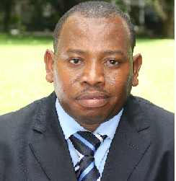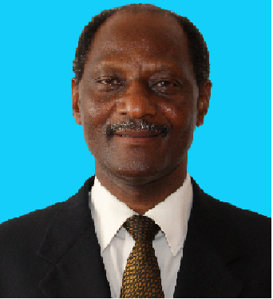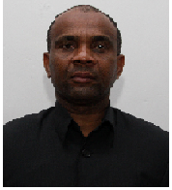

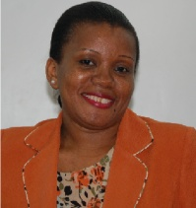

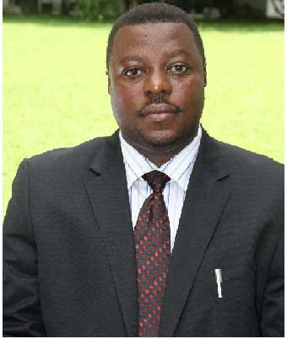

COUNCIL

DEPUTY SECRETARY REVOLUTIONARY

**SALMIN AMOUR ABDALLA**

PRESIDENT SECRETARY

**HARUB SHAIBU MUSSA**

PRINCIPAL SECRETARY, PRESIDENT’S OFFICE AND

CHAIRMAN OF REVOLUTIONARY COUNCIL

**SALUM MAULID SALUM**

MARIAM HAJI MRISHO

PRESIDENT DEPUTY SECRETARY

**SAID ABDALLA NATEPE**

DEPUTY SECRETARY, DEPARTMENT OF

INTERNATIONAL CO-OPERATION AND

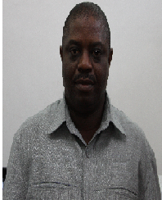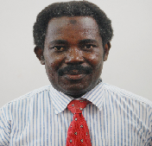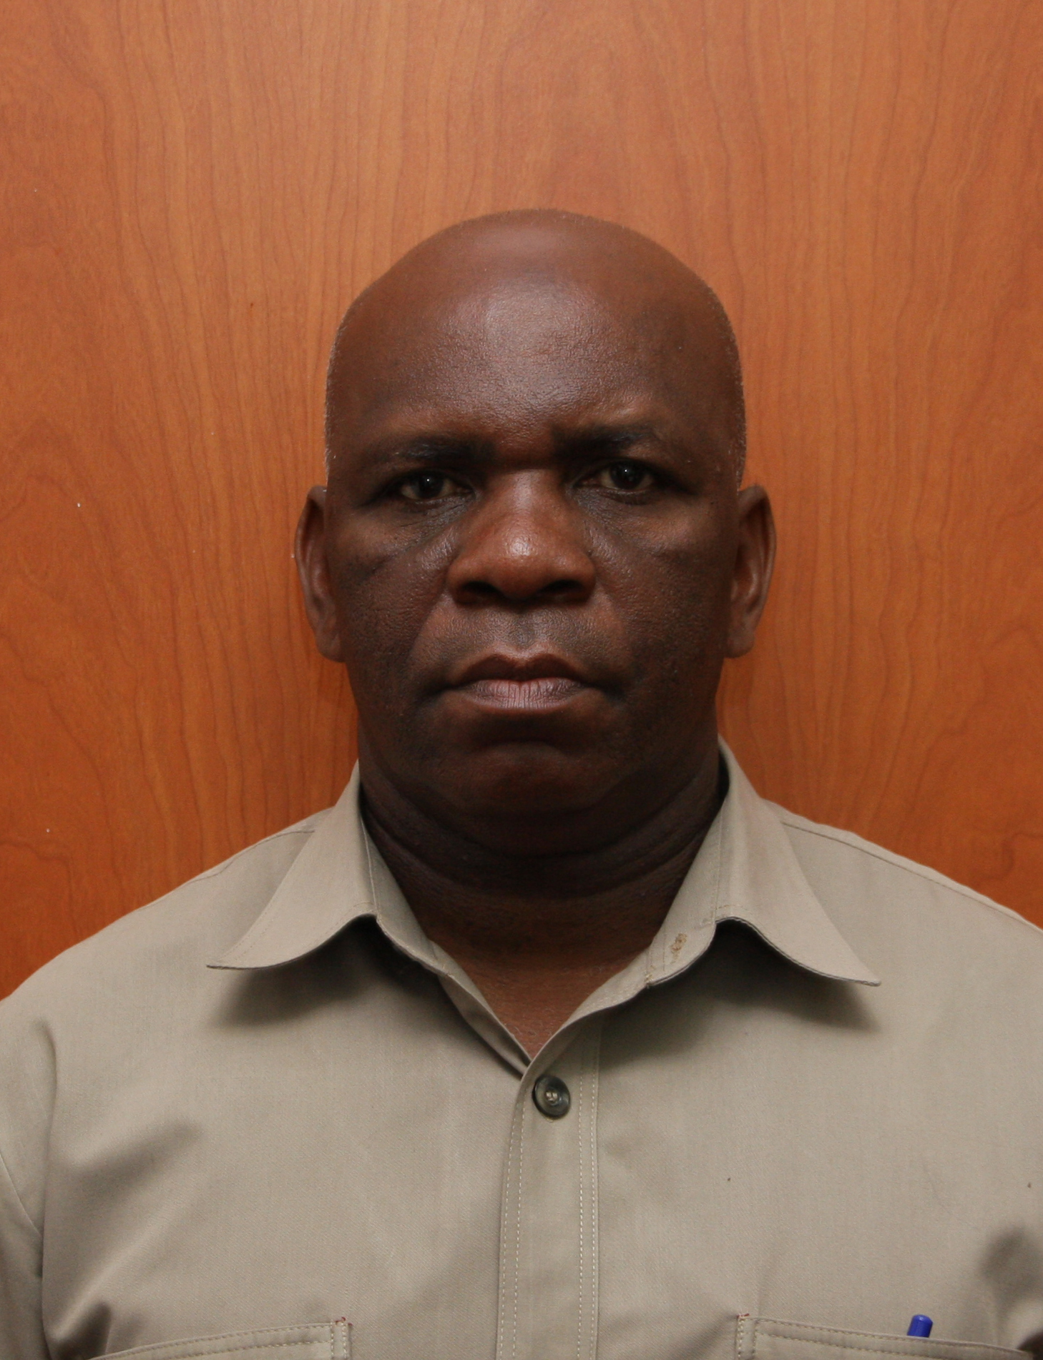

COORDINATION OF ZANZIBAR DIASPORA

**MKURUGENZI IDARA YA UTAWALA BORA ZANZIBAR**

**AMOUR HAMIL BAKARI**

DIRECTOR DEPARTMENT OF PLANNING, POLICY AND RESEARCH

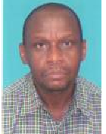

OF ZANZIBAR DIASPORA

DIRECTOR DEPARTMENT OF AND COORDINATION

**KHAMIS ALI KHAMIS**

COMMUNICATION AND INFORMATION

DIRECTOR DEPARTMENT OF

**HASSAN KHATIBU HASSAN**

RESOURCE MANAGEMENT AND ADMINISTRATION

DIRECTOR DEPARTMENT OF HUMAN

**MAKAME JUMA KHAMIS**

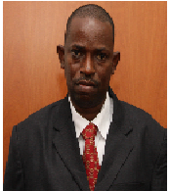

**KHADI JA** Kassim Ali

**SULEIMAN** Ali Suleiman

Mgeni Jailani Jecha

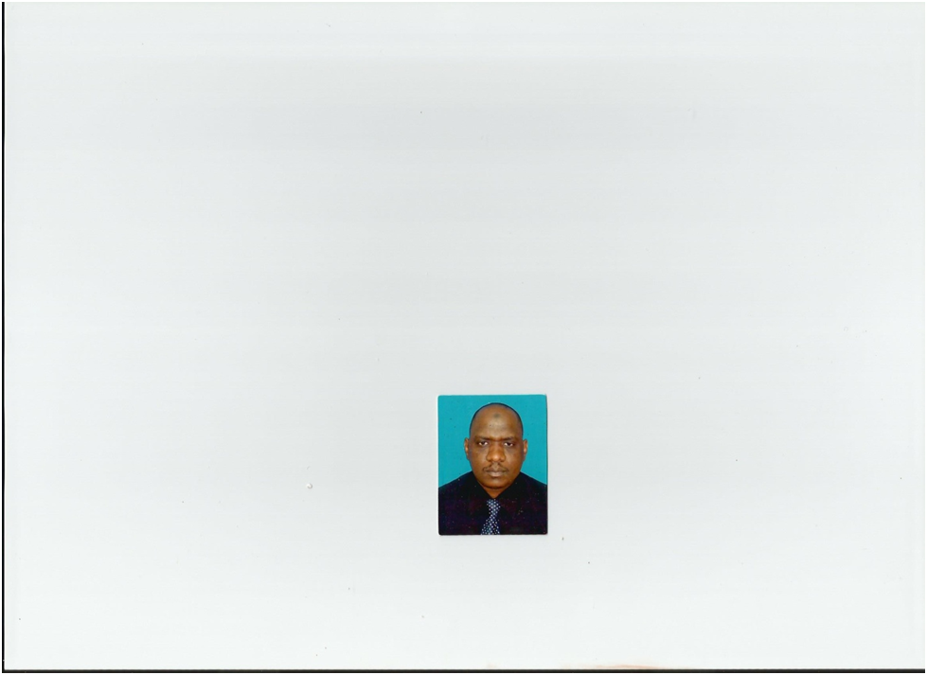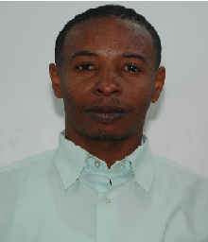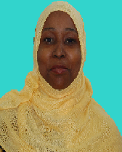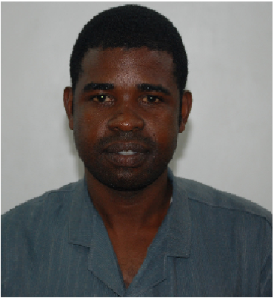

**MZEE ALI HAJI**

**SECRITARY OF REVOLUTION COUNCIL OF ZANZIBAR**



DIRECTOR DEPARTMENT OF GOVERNMENT SECURITY

**(GSO** UNIT)

**KOMBO GORA HAJI**

**ND.**